**Description and instructions for using the application**

**PidGct** is a desktop application that simulates a control panel (SCADA) in real time for monitoring and managing a plant for hot waste gas conditioning in order to prepare it for filtering before release out of plant.

The idea for creating this application stemmed from the intention to apply skills acquired during the learning of various areas of programming, as well as to improve existing skills and knowledge by overcoming challenges encountered during the development of the application.In addition, the challenge was to create a complex application that is based on a model of a real system, and that goes beyond the examples that are processed in the tutorials.

This document consists of the following parts:

1- Description of the plant

2- Starting the process and description of the process logic of the system.

3- Setting the chemical composition of gases

4- Regular process stop (plant shutdown)

5- Installation of the application

6- Uninstalling the application

7- Additional notes

**1 Description of the plant**

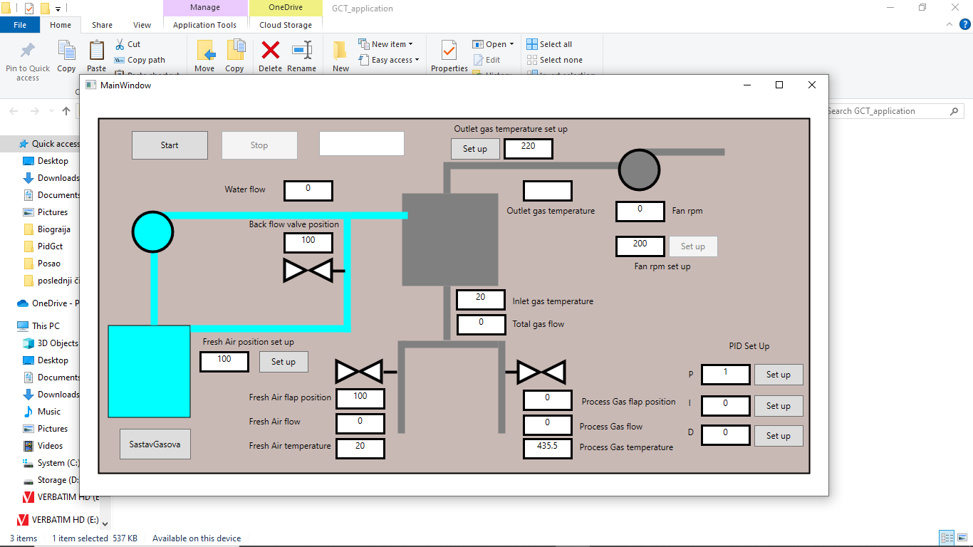

10

3

6

7

8

9

2

1

5

4

Figure 1 Main proces panel window

Legend:

1. Button for start sequence- imidately disabled after start sequence
2. Button for stop sequence imidately disabled after start sequence
3. Water pump with constant rpm, water flow is regulated by back flow valve position
4. Water tank
5. Gas condition tower
6. Cold (fresh air ) flap
7. Hot (proces gas) flap
8. Setup button for fan speed regulation
9. Fan
10. Buton for sub window opening for gas composition setup

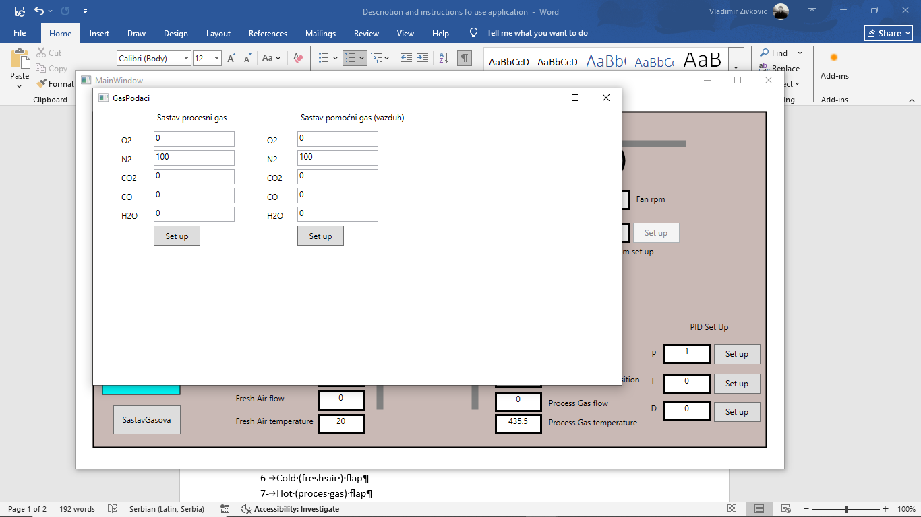

Figure 2 – Gas composiion set up subwindow

The plant consists of a gas pipeline that is divided into two segments in the initial part. Cold gas (or fresh air) flows through one, while process gas (hot gas) flows through the other. These segments are equipped with flaps (6 and 7) that regulate the gas flow in these segments. The flaps work synchronously - while one is closing, the other is opening. In this way, the flow of gas to the cooling tower (5), which is equipped with nozzles for spraying water, is regulated. This conditioned gas, after treatment in the cooling tower, is led further through the gas pipeline to the fan (9), which ensures the flow of gas through the system and sends the gas to the next point of the process.

Another part of the plant consists of a system for injecting water into the cooling tower. This system consists of a water tank (4), a constant-speed pump (3) and a system of water supply pipes for spray nozzles located in the cooling tower. On the return pipe to the water tank (4), there is an **automatic control valve** that **regulates the flow of the required amount of water** for gas cooling in the cooling tower.

The entire system is equipped with sensors, and points for adjustment and regulation for process control during operation.

Sensors in the system include:

* • Temperature sensors
* • Gas and water flow meters
* • Flap and valve position sensors
* • Fan speed sensor

The regulatory equipment consists of the following points:

* • Adjusting the position of the flaps for regulating the flow through the segments of the gas pipeline with cold gas or hot gas (Fresh Air position set up)
* • Fan rpm set up
* • Setting the outlet gas temperature after the cooling tower (Outlet gas temperature set up)

In order for the application to be as close as possible to the real system, the possibility of changing the chemical composition of the gases entering the process has been realized, because the heat capacity of the gas, and therefore its temperature, also depends on the chemical composition of the gas. This is enabled in the subwindow (Figure 2 Gas composition set up subwindow), which is opened by clicking on the button "Chemical composition of gases" (10).

**2 Starting the process and description of the process logic of the system**

By clicking the "Start" button (1), the fan (9) turns on. The visualization shows the start of the fan by changing the color of the fan and the gas line from gray to green.

After starting, the fan accelerates to 800 rpm in intervals of 100 revolutions. This does not happen in a real system and is done here to bring the application to the working state of the process as soon as possible.

At the moment of starting, the gas flow control valve in segment (6) is open 100%, while the process gas valve (7) is closed (0%).

When the fan speed reached 800 rpm, the fan rpm can be changed by entering a new value in the input field (Fan rpm set up) and clicking the "Set up" button. Setting the number of revolutions should be in the range of 800-990 rpm. The fan speed is changing in steps of 1 rpm/s until new set up value is reached.

The redistribution of the flow of cold and hot gas in the pipeline segments is adjusted by setting a new value for the position of the fresh air flap (6) by entering the new value in the appropriate field and then clicking the "Set up" button. Valves on gas pipeline segments work synchronously and are set to a new set position at a speed of 1%/s.

Part of the plant for water injection is switched off until certain process conditions are reached ("Outlet gas temperature").

* The water injection plant is switched on when the temperature of the gas behind the cooling tower ("Outlet gas temperature") reaches a value that is 20 degrees C lower than the set temperature of the outlet gases (Outlet gas temperature set up). The water pump (3) is turned on and the automatic back flow valve remains in the initial position of 100%. This ensures the readiness of the system to perform cooling by water injection, and the opening of the valve 100% ensures the recirculation of the complete amount of water back into the water tank (4). The visualization shows the transition of the color of the pump and the segment of the water flow system from light blue to dark blue.
* When the value of the outlet gas temperature behind the cooling tower ("Outlet gas temperature") reaches the value of the set temperature of the outlet gases from the cooling tower (Outlet gas temperature set up), a signal is sent to the back flow automatic valve, which is set to a new position. The valve displacement is in steps of 1%/s. By closing the valve, it is possible to direct part of the water to the nozzles of the cooling tower and the cooling of the gas begins. This process occurs in cycles until the temperature of the outlet gases ("Outlet gas temperature") and the set temperature of the outlet gases from the cooling tower (Outlet gas temperature set up) are equalized. In reality (and in this application) this is unlikely, so the new position of the valve will be set according to the difference between these two temperatures. In other words, the outlet gas temperature from the cooling tower ("Outlet gas temperature") will oscillate in a narrow temperature band around the set temperature of the outlet gases from the cooling tower (Outlet gas temperature set up), and in accordance with the positive or negative difference between these two temperatures, the new position of the back flow valve (Back flow valve) will be set according to the valve stroke of 1%/s (closes or opens).

Setting the value of the temperature of the outlet gas from the cooling tower (Outlet gas temperature set up) allows setting the threshold for turning on and off the water injection system, as well as the value of the temperature of the outlet gases from the cooling tower ("Outlet gas temperature") that should be achieved. Setting this temperature is done by entering the appropriate value in the field (Outlet gas temperature set up) and clicking on the "Set up" button. It is recommended that this temperature be set before starting the plant, or during the operation of the plant, change it in small steps, which corresponds to the operation of this plant in reality.

**3 Setting the chemical composition of gases**

To better approximate real-world process conditions, the application allows the user to configure the chemical composition of the gases. This is made possible by opening the sub-window by clicking on the button "Chemical composition of gases" (10). This sub-window should be opened after starting the application by pressing the "Start" button(1), otherwise no values are displayed in the sub-window.

The default configuration in the application reflects real values for **process gas**, while for **cold gas**, it corresponds to the chemical composition of ambient air.

Note that the **nitrogen (N₂) percentage is automatically adjusted based on the configured oxygen (O₂) percentage.**

If you intend to change these parameters, it is **strongly recommended** to write down the current values beforehand, as the system **currently does not support restoring default (initial) values.**

**4 Regular process stop (plant shutdown)**

By clicking on the "Stop" button (2) it is possible to stop the plant regularly.

Plant shutdown occurs in the following sequences:

1. When the 'Stop' button (2) is pressed, the fresh air flap is automatically set to 100%. Following this new setting, both the fresh air and process gas flaps adjust to their respective positions at a rate of 1% per second
2. In accordance with the new positions of the fresh air and process gas flaps (6 and 7), the inlet and outlet temperature of the cooling tower gas is changed, and thus back flow valve for the water flow, is forced to new position with a stroke of 1%/s in accordance with the set temperature of the outlet gas from the cooling tower (Outlet gas temperature set up).
3. When the difference in the value of the set temperature of the outlet gas from the cooling tower (Outlet gas temperature set up). and the temperature of the outlet gases from the cooling tower ("Outlet gas temperature") becomes higher than 20 degrees C, the water pump (3) is turned off. The visualization changes color from dark blue to light blue for the pump and water circulation pipe system in the water supply plant.
4. After reaching the position of the fresh air flap (6) of 100%, the fan (9) is turned off. The visualization for gas flow and fan operation changes from green to gray.
5. The sequence ends and the plant is stopped. Clicking on "Start" button (1) again the plant can be restarted.

**5 Installation of the application**

1 Unzip the zipped file GCT_application in the folder where it is located

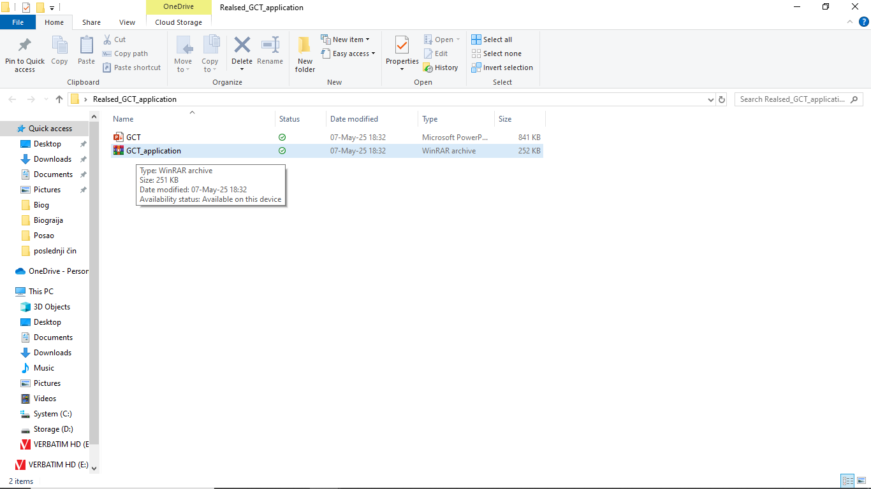

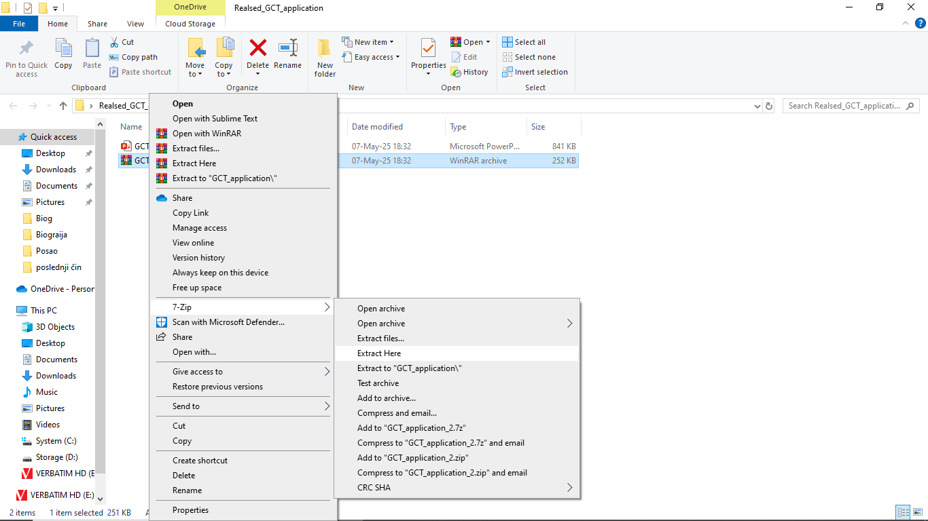

2 Open the unpacked folder and double-click on setup

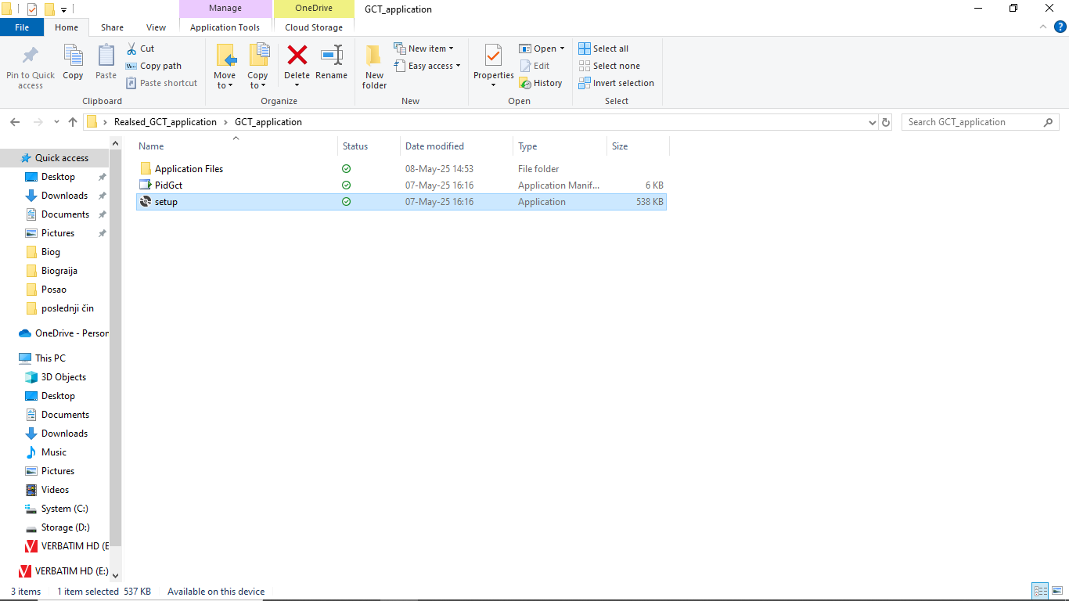

3 A pop-up window will open to start the installation

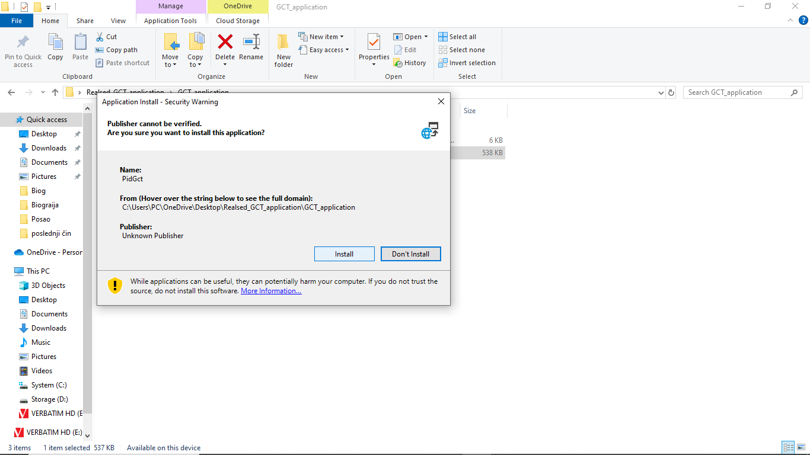

Clicking on install starts the installation process and after completion the application opens and is ready for use

4 The installed application can be found by clicking the "Start" button in the taskbar.

The application can be dragged to the desktop or placed in a location by selecting an option in the "More" drop-down list

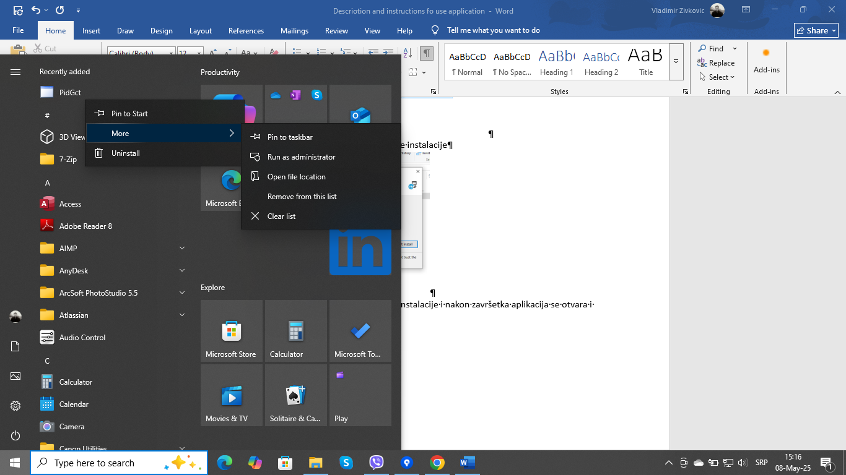

**6 Uninstalling the application**

1 The installed application can be found by clicking the "Start" button in the taskbar.



2 Clicking on the "Uninstall" selection field opens a window where installed programs are located on the Control Panel.

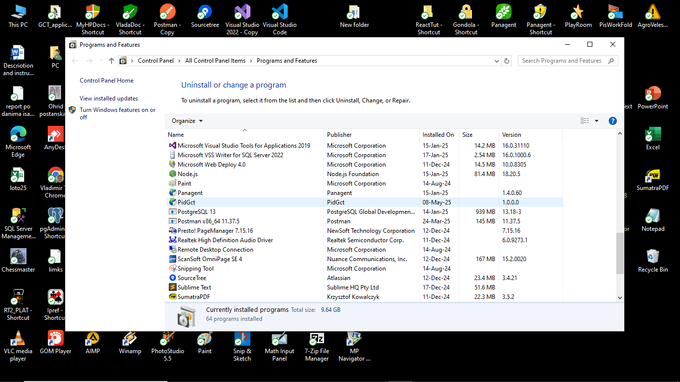

3 Find "PidGct" and right-click to open the uninstall option

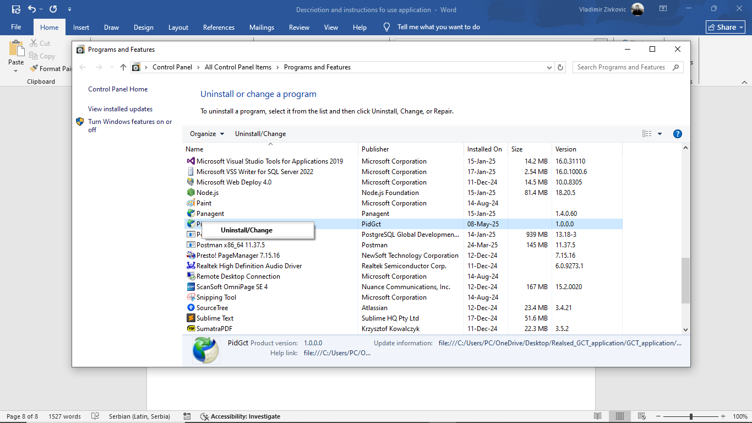

and click on the offered option.

4 A pop-up window opens with the option to uninstall

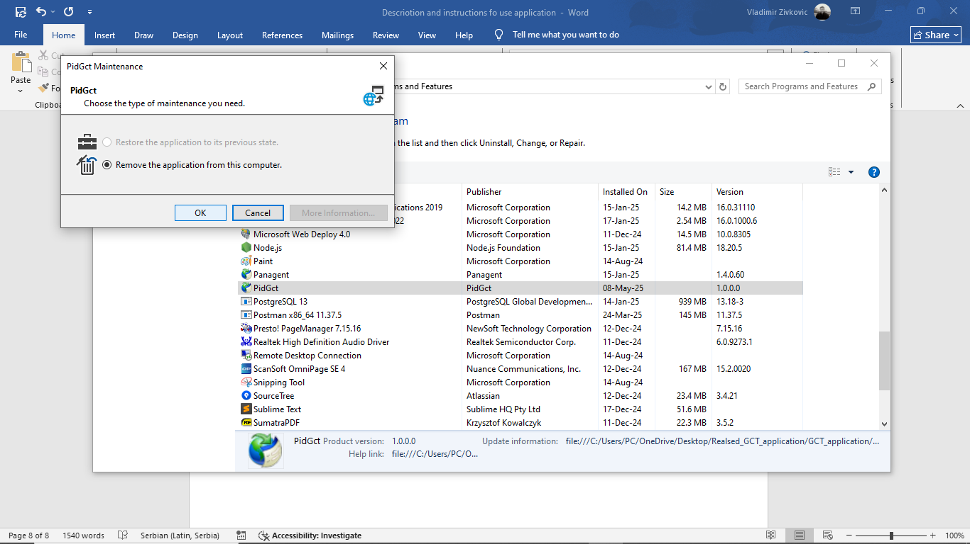

5 By clicking "OK" starts the uninstallation

**7 Additional notes**

The application was developed in the C# programming language, using the WPF framework and the MVVM architectural pattern.

The calculation of the required amount of water for gas cooling is done using the formula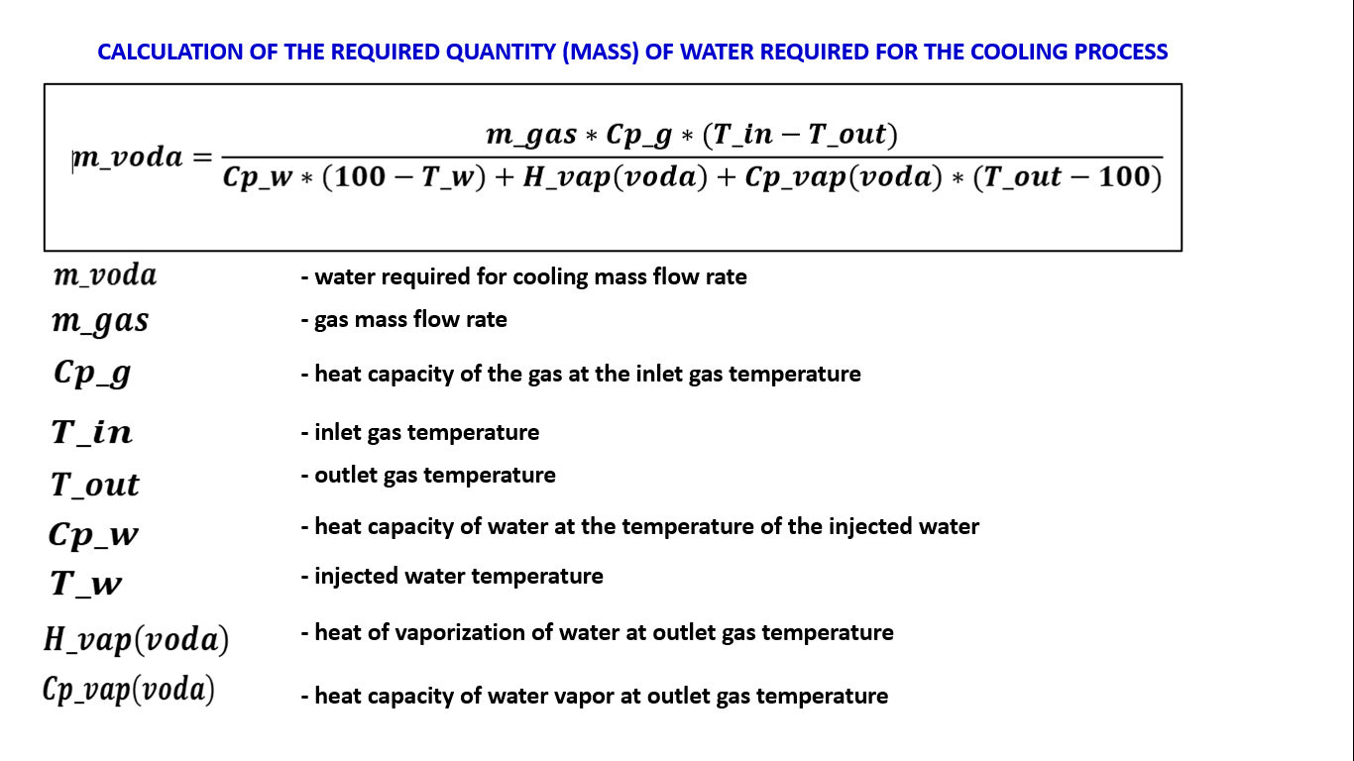

The gas flow rate value depending on the fan speed is calculated from the fan characteristic diagram. The flow rate value for a specific example is found as the x-axis value at the intersection point of the blue and red curves.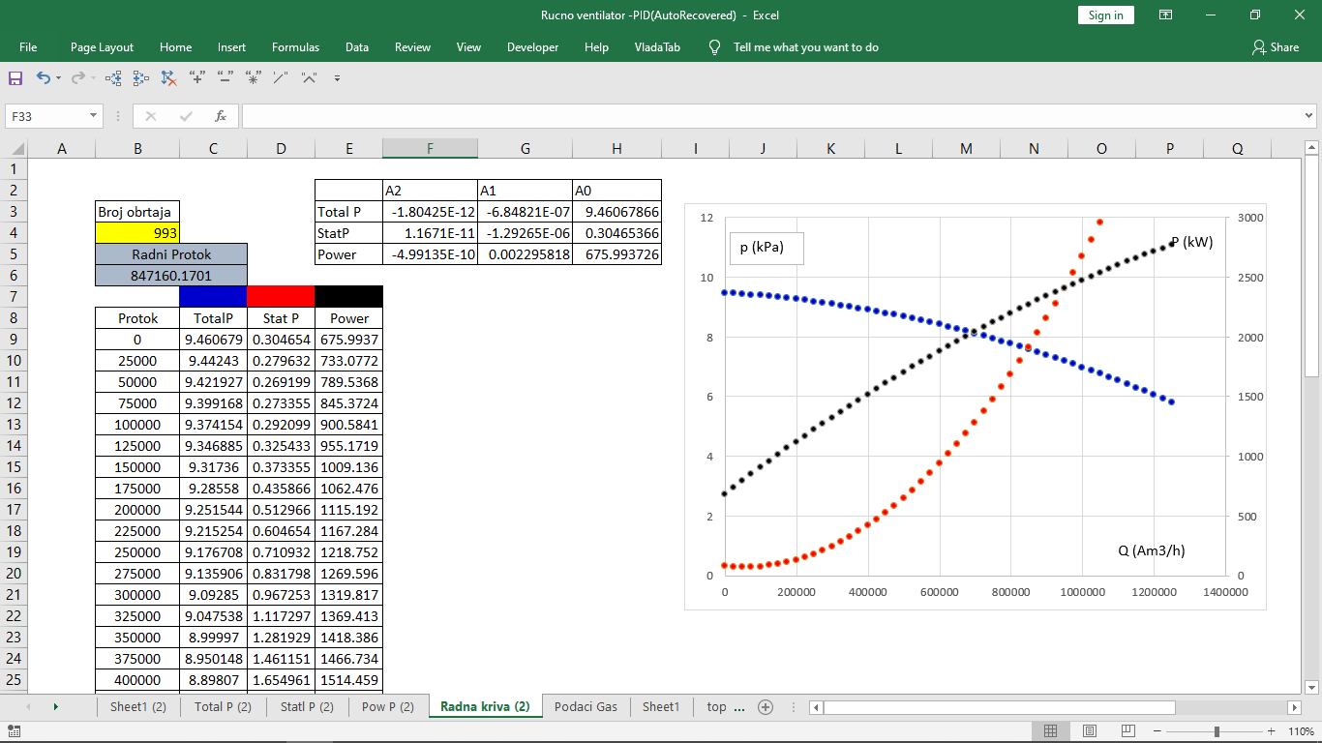

The application uses the value of the heat of vaporization of water (Hvap) as a dependent value of the current process temperature, this also applies to the heat capacities of all process components.

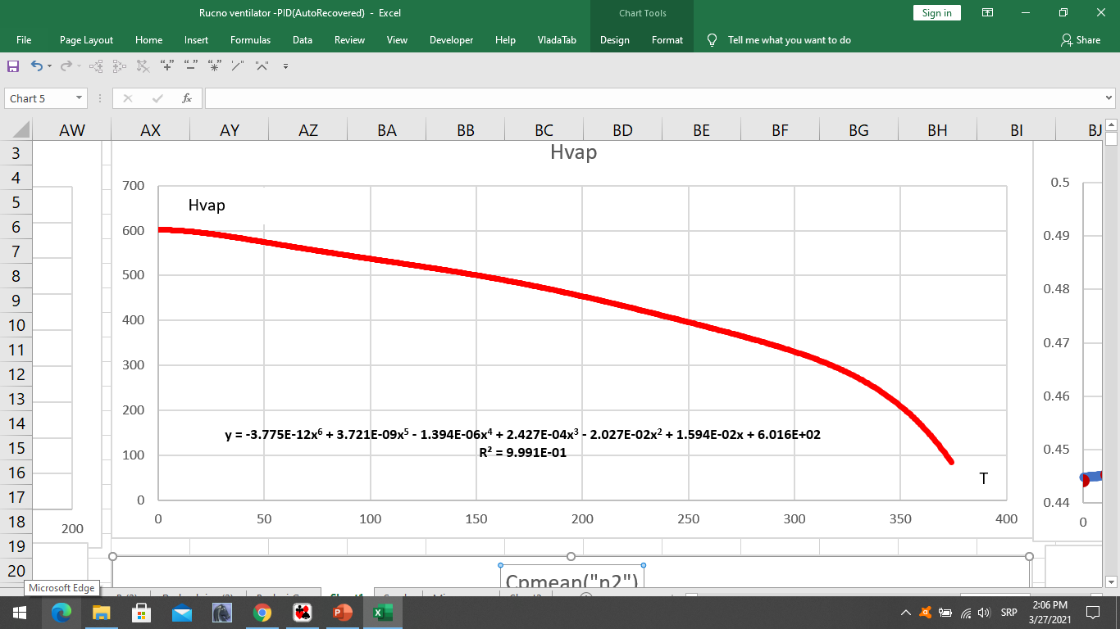

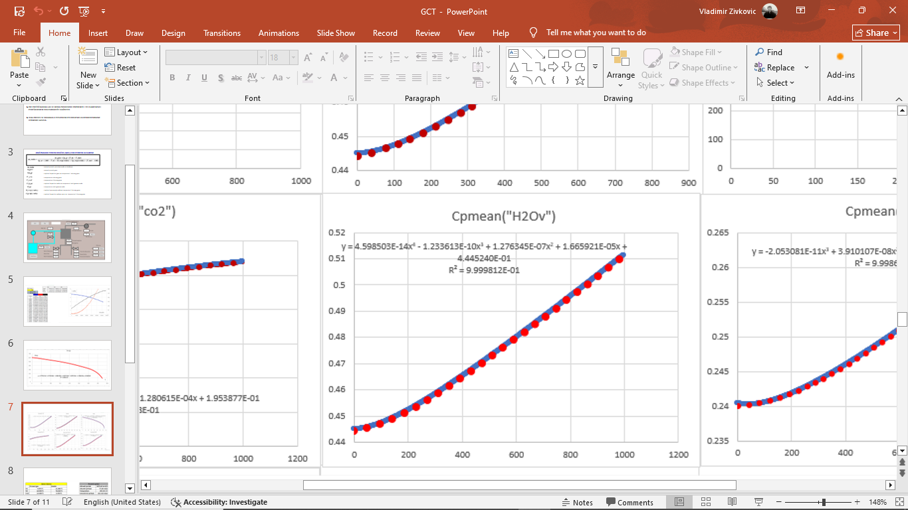

The value of the inlet temperature to the cooling tower is not just an arithmetic calculation of the percentage shares of hot and cold gas, but is based on all thermodynamic characteristics and chemical composition of these gases during their mixing.

The following simplifications have been applied in the application:

* There is no noise or slight variations in the values coming from the sensor
* The gas density is ignored as a dependent quantity on its temperature
* All changes are instantaneous, there is no delay that exists in a real system due to the size of the plant and the distance between the source of change and the sensor for registering the change
* The presence of the on/off valve on the water supply to the cooling tower is ignored, its presence is assumed.

Author:

Vladimir Živković